Thank you for purchasing

Monster Caddy ®

Holds More Items, More Securely, Than All Other Shower Caddies!

How To Install Monster Caddy
Monster Caddy is simple to install. Monster Caddy's mounting bar acts as a guide or template so there is no need to measure for the second stud. Since the mounting slots are spaced exactly 16" apart it greatly enhance the likelihood of finding the other stud (if framed correctly).

THINGS YOU SHOULD KNOW ABOUT YOUR SHOWER

Fiberglass showers have a 1” mounting lip that surrounds the unit. It is used for nailing the shower unit to the studs. Please pre-drill the holes with a tiny bit to verify you will not encounter one of these nails. If you do, simply slide the caddy slightly right / left to avoid the nail. Be sure to use the stud finder far enough above the mounting lip so as not to confuse it. Since the center of the mounting guide button is 11/16” (17.5mm) above the ledge you “could” mount Monster Caddy anywhere so long as you hit the fiberglass lip. **

Tile, Marble or Granite showers typically adhered to a cement board (i.e. Hardiebacker or Wonderboard) with an adhesive i.e. quickset. The cement board can make it difficult to find the stud, but the good news is that the cement board is dense enough to hold the mounting guide buttons in place so it can be mounted anywhere. **

Corian or other Solid Surface shower installations make it easy to find the stud since they typically use silicon to adhere to greenboard … which is a just a moisture resistant drywall. **

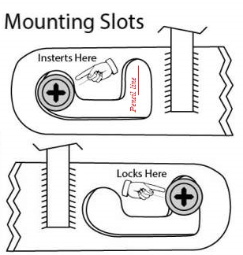
Tools needed: Screwdriver (or cordless driver), stud finder & pencil. ***

Step 1: Decide where you would like to mount your Monster Caddy
Step 2: Locate the stud and make a pencil mark just above shower ledge
Step 3: Place caddy on ledge with pencil line is in the middle of the slot
Step 4: Place one guide button into the mounting slot
Step 5: Drive screw through the guide button into the stud *
Step 6: Repeat steps 4-5 for the other side of the mounting bar

* Do not over tighten the mounting buttons as this will crush the drywall and sink the mounting button into the wall.
** Remember, when installed properly the mounting button does not hold any weight, they ONLY keep Monster Caddy
from slipping off the ledge.
*** To view the install video visit: www.MonsterCaddy.com

